Digital foot print analyzer

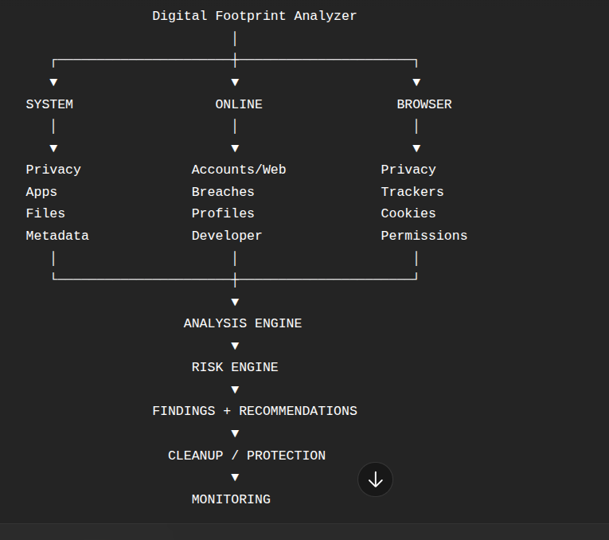

System design
1.System Boundary and Scope
The Digital Footprint Analyzer is a system-level application designed to help individual users understand, analyze, and manage their digital footprint.
A digital footprint consists of traces of information generated through a user's interaction with computer systems, web browsers, online services, websites, social platforms, developer platforms, and digital files.
The proposed system will analyze both:
- Local digital footprint generated on the user's system.
- Online/public digital footprint available through authorized or publicly accessible sources.
The system will also provide risk analysis, privacy findings, recommendations, and user-controlled remediation where technically possible.
Objectives of the System
- To identify the user's digital footprint from local and online sources.
- To analyze the privacy and security implications of the collected information.
- To identify potentially sensitive or unnecessary digital exposure.
- To provide an understandable risk assessment.
- To recommend actions for reducing digital exposure.
- To allow users to perform selected cleanup/remediation actions with explicit consent.
- To provide a separate public-footprint lookup capability for publicly accessible information.
Target Users
The initial target users of the system are individual users.
The application is intended for users who want to:
- Understand their digital presence.
- Identify privacy risks.
- Discover exposed information.
- Review their browser and system footprint.
- Check their public online presence.
- Reduce unnecessary digital traces.
The system may be extended to other user groups in future versions.

Major Digital Footprint Categories

A. Online Footprint
Includes:
- Email exposure
- Username exposure
- Public profiles
- Social profiles
- Developer profiles
- Public web presence
- Public mentions
- Data breach exposure

B. System Footprint
Includes:
- Operating system information
- Installed applications
- Running processes
- Startup applications
- Network configuration
- System privacy/security information

C. Browser Footprint
Includes:
- Browser information
- Browsing history
- Cookies
- Browser extensions
- Browser permissions
- Trackers
- Download history
- Site data

D. File and Metadata Footprint
Includes:
- Local files selected by the user
- Image metadata
- Document metadata
- Location metadata
- Author information
- Creation/modification information

System Operating Modes

Mod 1 :my footprint

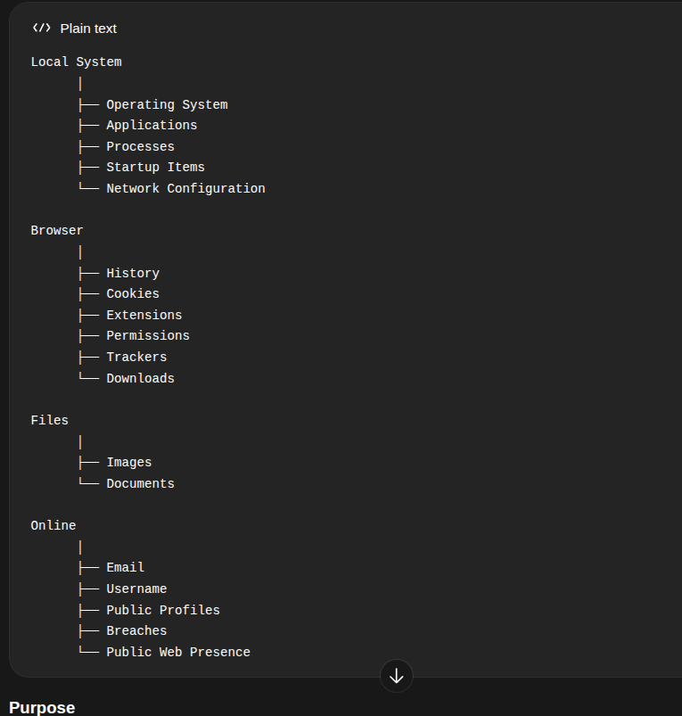
Mod 2: public footprint lookup
This mode analyzes publicly or legitimately accessible information associated with an identifier.
Possible inputs include:
- Username
- Email
Possible sources include:
- Public profiles
- Public websites
- Public mentions
- Developer platforms
- Social platforms
- Public breach information

Restrictions
Public Footprint Lookup will not access:
- Private accounts
- Private messages
- Another person's computer
- Browser history
- Cookies
- Local files
- Installed applications
- Other private system information

System boundary diagram
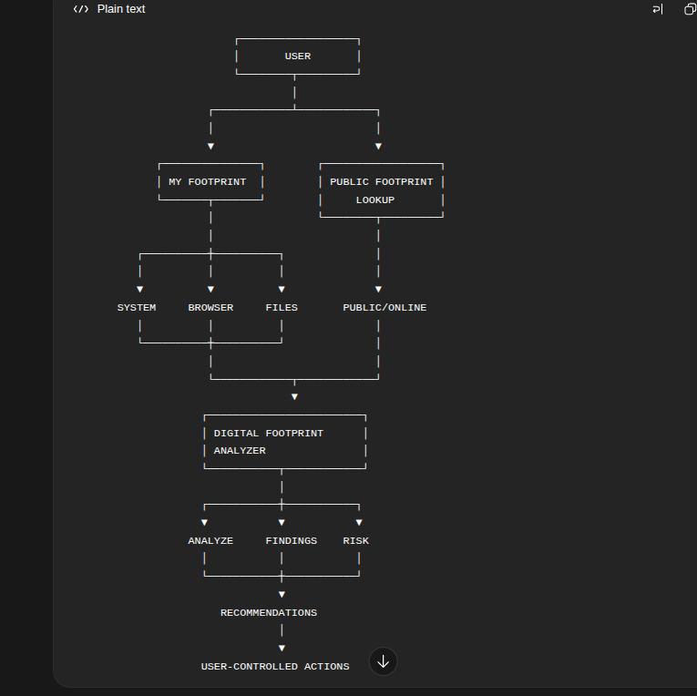

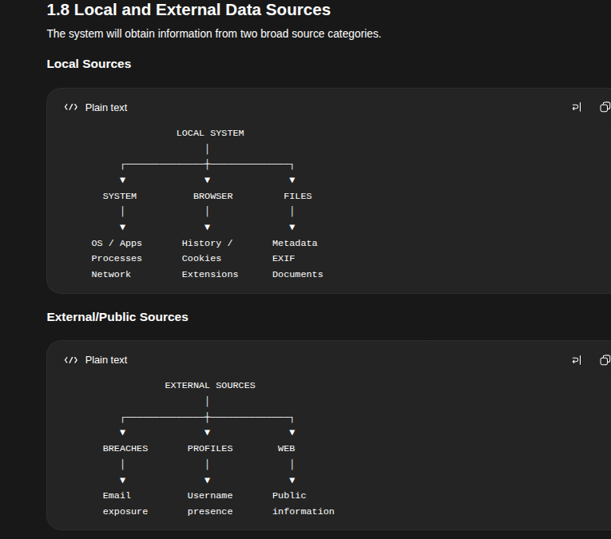

Privacy Boundary
rivacy is considered a core system requirement.
The application should follow the principle:
Collect and process only the information necessary for the requested analysis and keep sensitive information local whenever possible.
The system should:
- Clearly inform the user what is being analyzed.
- Request appropriate permissions.
- Avoid unnecessary collection of personal information.
- Avoid uploading private files without explicit user authorization.
- Avoid storing sensitive information unnecessarily.
- Protect any information that must be stored.
- Allow the user to control cleanup actions.

Security and Ethical Boundary
The system is intended as a personal privacy and security tool.
It must not:
- Bypass authentication.
- Bypass CAPTCHA or other security controls.
- Access private accounts.
- Access private messages.
- Retrieve actual leaked passwords.
- Secretly monitor another person's computer.
- Perform unauthorized system access.
- Automatically delete data without user approval.
The system should operate only on:
- The user's own system/data, with appropriate authorization.
- Publicly accessible information.
- Information obtained through legitimate/authorized services.

Remediation Boundary
The system will not claim that it can completely erase a user's digital footprint.
Instead, the objective is:
Identify removable digital traces and provide user-controlled remediation where technically and legally possible.
Remediation may be divided into three categories:

Direct Cleanup
The application can perform the action directly.
Example:
Remove metadata from a selected image.

Authorized Cleanup
The application performs the action after obtaining user permission.
Example:
Clear selected browser data.

Guided Cleanup
The application guides the user through the action.
Example:
Open the account's official settings/deletion page.

User control Actions
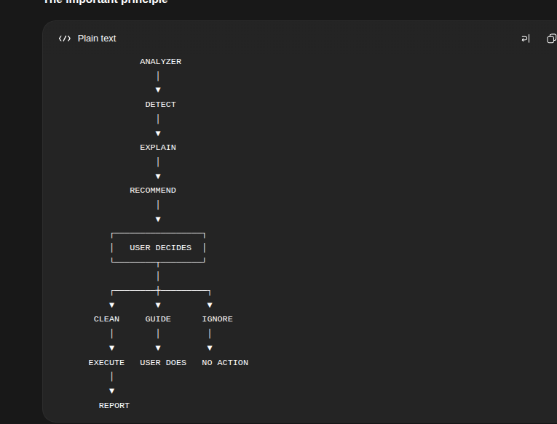

Scope Summary
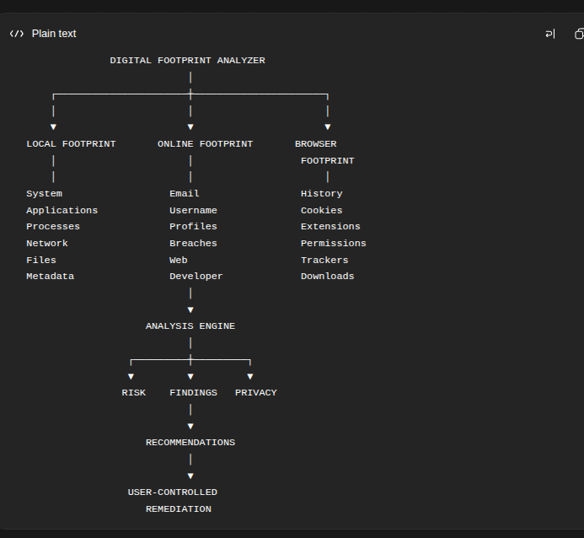

System actors

2.1 Introduction
An actor is an entity that interacts with the Digital Footprint Analyzer from outside the system. Actors may be human users or external systems that provide information or services required by the application.
For the initial version of the Digital Footprint Analyzer, the system will have one primary human actor and several external/system actors.

2.2 Primary Human Actor — User
The User is the primary human actor of the Digital Footprint Analyzer.
The system is designed mainly for individual users who want to understand, analyze, and manage their digital footprint.
The user can:
- Select the required analysis mode.
- Provide an email address or username for analysis.
- Authorize access to local system information.
- Analyze browser and local file information.
- View detected digital footprint information.
- Review privacy and security risks.
- View recommendations.
- Select the actions they want to perform.
- Approve or reject cleanup actions.
- View the results of completed actions.
- View or generate the final analysis report.
The user remains in control of the analysis and remediation process.

2. System Actors

2.1 Introduction
An actor is an entity that interacts with the Digital Footprint Analyzer from outside the system. Actors can be human users or external systems that provide information required for digital footprint analysis.
The Digital Footprint Analyzer will have one primary human actor and several external/system actors.

2.2 Human Actor

2.2.1 User
The User is the primary human actor of the Digital Footprint Analyzer. The system is designed for individual users who want to understand, analyze, and manage their digital footprint.
The User can:
- Select the required analysis mode.
- Provide an email address or username for analysis.
- Authorize access to local system information.
- Request analysis of the local system, browser, and files.
- View detected digital footprint information.
- Review privacy and security risks.
- View recommendations.
- Select the actions they want to perform.
- Approve or reject cleanup actions.
- View the results of completed actions.
- View or generate analysis reports.
The User remains in control of the analysis and remediation process.

2.3 External/System Actors
The following external systems interact with the Digital Footprint Analyzer.

2.3.1 Operating System
The Operating System provides authorized system-level information required for local footprint analysis.
The initial version will support:
- Windows
- Linux
The analyzer may obtain information such as:
- Operating system details
- Installed applications
- Running processes
- Startup applications
- Network configuration
- Other authorized system-level information
Windows and Linux may use different operating-system-specific mechanisms, while the analyzer will convert the collected information into a common format for analysis.

2.3.2 Web Browser
The Web Browser provides information required for browser footprint analysis.
The analyzer may examine authorized browser information such as:
- Browser details
- Browsing history
- Cookies
- Browser extensions
- Site permissions
- Download history
- Site data
- Tracking-related information
Access to browser data will be performed only with appropriate user authorization.

2.3.3 File System
The File System provides access to user-selected local files for file and metadata analysis.
The analyzer may examine:
- File information
- Image metadata
- Document metadata
- File creation and modification information
- Author information
- Location metadata where available
The system should not access or upload private files unnecessarily. File analysis should be performed only on files selected or authorized by the user.

2.3.4 External Breach and Data Services
External breach and data services provide publicly or legitimately accessible information required for online footprint analysis.
These services may be used to:
- Check whether an email address appears in known data breaches.
- Obtain available breach information.
- Support online exposure analysis.
The system will use only legitimate services and will not retrieve or display actual leaked passwords or other unauthorized sensitive information.

2.3.5 Public Web and Websites
The Public Web and Websites provide publicly accessible information associated with identifiers such as usernames and email addresses.
The analyzer may use public information to identify:
- Public profiles
- Social-media profiles
- Developer profiles
- Websites and domains
- Public mentions
- Publicly indexed information
- Other publicly accessible digital presence
The system will not attempt to bypass authentication, CAPTCHA, privacy controls, or access private accounts or messages.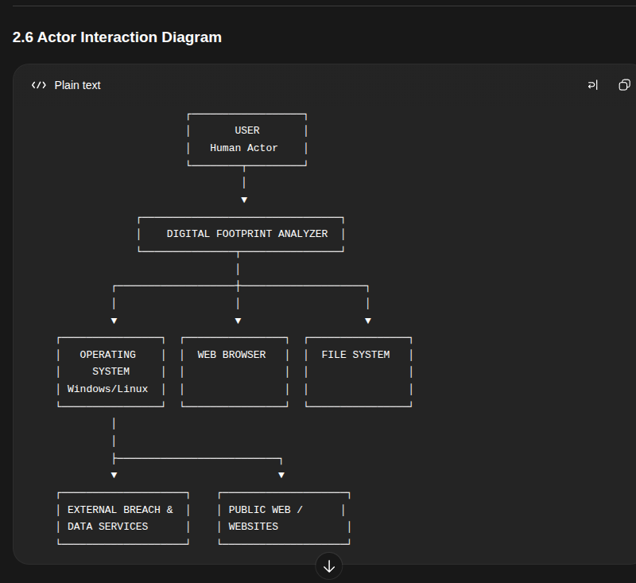

Use Case Analysis

3.1 Introduction

A use case describes an interaction between an actor and the system to achieve a specific objective. In the Digital Footprint Analyzer, the primary actor is the User. The user can analyze their own digital footprint or perform a lookup of publicly and legitimately accessible information.

The system provides two primary modes of operation:

My Footprint

Public Footprint Lookup

Each mode supports both Full Scan and Individual Scan.

3.2 Use Case 1 — My Footprint

The My Footprint use case allows the user to analyze their own digital footprint using information from their local system and publicly/legitimately accessible online sources.

The user may analyze:

System footprint

Browser footprint

File and metadata footprint

Email exposure

Username exposure

Public online presence

The user must provide appropriate authorization when the system requires access to local information.

3.3 Use Case 2 — Public Footprint Lookup

The Public Footprint Lookup use case allows the user to analyze publicly and legitimately accessible information associated with an identifier such as a username or email address.

The system may identify:

Public profiles

Social profiles

Developer profiles

Public web presence

Public mentions

Known breach exposure

Other supported publicly indexed information

The system shall not attempt to access private accounts, private messages, authentication-protected information, or systems belonging to another person.

3.4 Scan Types

Both primary use cases provide two scanning options.

3.4.1 Full Scan

A Full Scan performs all relevant analysis supported by the selected mode.

My Footprint — Full Scan

The system analyzes all authorized and supported categories, including:

System footprint

Browser footprint

File and metadata footprint

Email exposure

Username exposure

Public online presence

Public Footprint Lookup — Full Scan

The user provides an identifier such as a username or email address. The system performs all relevant public and legitimate checks supported by the application for that identifier.

Full Scan does not mean searching the entire internet. It means performing all relevant analysis modules that are supported by the system.

3.4.2 Individual Scan

An Individual Scan allows the user to select a specific analysis category rather than performing a complete scan.

My Footprint — Individual Scan

Possible individual scans include:

System Scan

Browser Scan

File and Metadata Scan

Email Scan

Username Scan

Public Presence Scan

Public Footprint Lookup — Individual Scan

Possible individual scans include:

Username Scan

Email Exposure Scan

Public Profile Scan

Web Presence Scan

Public Mention Scan

The exact available scans depend on the information provided and the analysis capabilities implemented by the system.

3.5 Use Case Flow
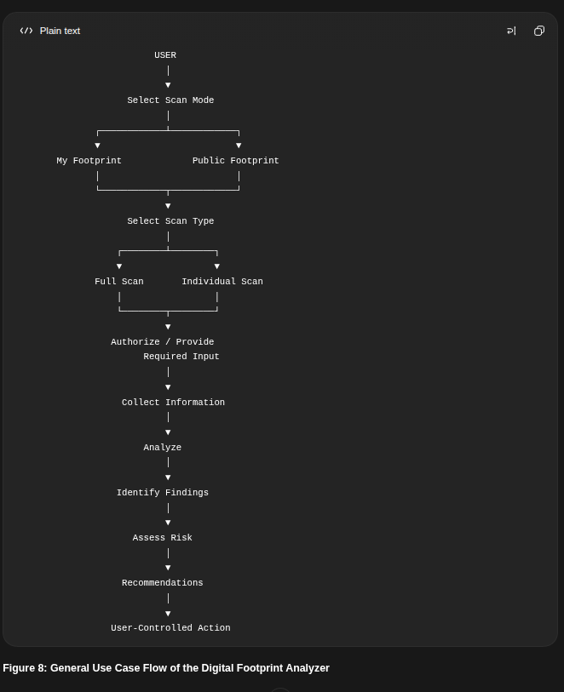

3.6 Findings and User-Controlled Actions
After an analysis is completed, the system presents the detected findings and their associated risks.
The system then provides recommendations based on the findings.
If a safe and technically feasible action can be performed by the application, the system may provide the action to the user after obtaining confirmation.
If the system cannot directly perform the action, it shall provide a recommendation or guided remediation for the user.
Use case diagram
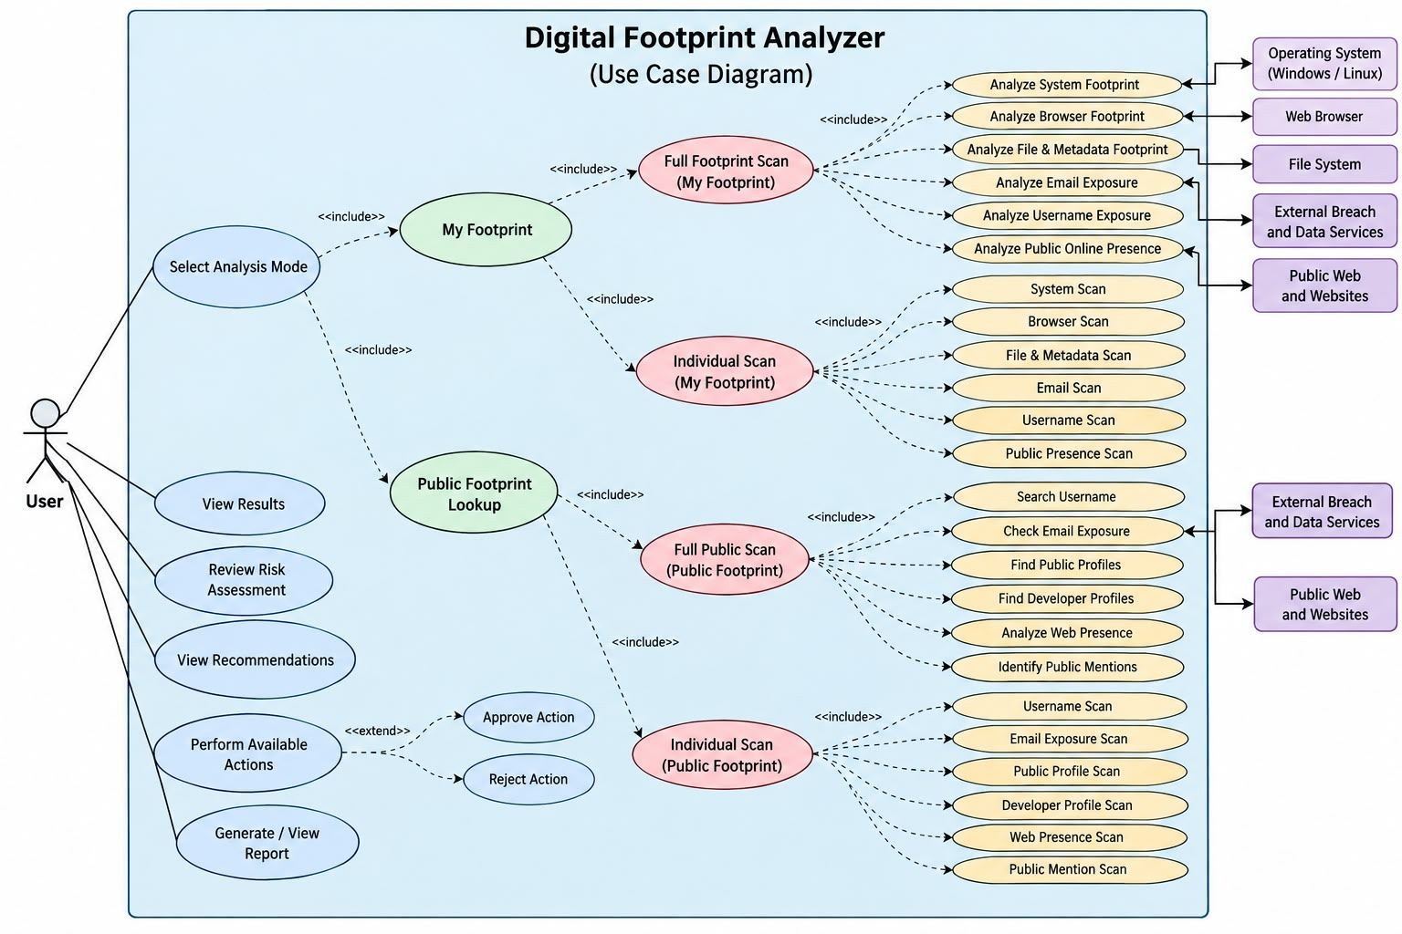

4. System Workflow

4.1 Overview
The Digital Footprint Analyzer follows a user-driven workflow in which the user selects the type and scope of analysis, provides the required information or authorization, and reviews the results before taking any remediation action.
The overall workflow consists of the following stages:
- Launch Application
- View Home Dashboard
- Start New Analysis
- Select Analysis Mode
- Select Scan Type
- Provide Required Input / Grant Authorization
- Collect Relevant Information
- Analyze Collected Information
- Identify Findings
- Assess Privacy and Security Risks
- Present Results and Recommendations
- Perform User-Controlled Actions, where possible
- Generate/View Report
- Return to Dashboard

┌──────────────────────┐
│ START │
└──────────┬───────────┘
│
┌──────────▼───────────┐
│ HOME DASHBOARD │
└──────────┬───────────┘
│
┌──────────▼───────────┐
│ START ANALYSIS │
└──────────┬───────────┘
│
┌──────────▼───────────┐
│ SELECT ANALYSIS MODE │
└──────────┬───────────┘
│
┌─────┴────────────────────┐
┌────▼──────────────┐ ┌─────────▼──────────────┐
│ MY FOOTPRINT │ │ PUBLIC FOOTPRINT LOOKUP│
└────┬──────────────┘ └─────────┬──────────────┘
│ │
Select Scan Type Select Scan Type
Full / Individual Full / Individual
│ │
Authorization / Input Identifier / Input
│ │
└─────┬────────────────────┘
┌──────────▼───────────┐
│ COLLECT INFORMATION │
└──────────┬───────────┘
│
┌──────────▼───────────┐
│ ANALYZE │
└──────────┬───────────┘
│
┌──────────▼───────────┐
│ IDENTIFY FINDINGS │
└──────────┬───────────┘
│
┌──────────▼───────────┐
│ ASSESS RISK │
└──────────┬───────────┘
│
┌──────────▼───────────┐
│ RESULTS & │
│ RECOMMENDATIONS │
└──────────┬───────────┘
│
┌──────────▼───────────┐
│ USER-CONTROLLED │
│ ACTIONS │
└──────────┬───────────┘
│
┌──────────▼───────────┐
│ REPORT / SUMMARY │
└──────────┬───────────┘
│
┌──────────▼───────────┐
│ HOME DASHBOARD │
└──────────────────────┘
 Step 1 — Launch Application
When the user launches the Digital Footprint Analyzer, the system initializes the application and displays the Home Dashboard.
mputer or online presence.
This ensures that analysis is initiated only by the user's decision.

4.4 Step 2 — Home Dashboard
The Home Dashboard acts as the central entry point of the application.
It provides access to:
- Start New Analysis
- My Footprint
- Public Footprint Lookup
- Recent analysis results
- Latest footprint summary, when available
- Reports, when available
The exact visual design of the dashboard will be defined later during the user-interface design stage.

4.5 Step 3 — Select Analysis Mode
The user selects one of the two analysis modes:

My Footprint
Used to analyze the user's own:
- System
- Browser
- Files and metadata
- Email exposure
- Username exposure
- Public online presence

Public Footprint Lookup
Used to analyze publicly and legitimately accessible information associated with an identifier such as:
- Username
- Email address
The system then proceeds according to the selected mode.

4.6 Step 4 — Select Scan Type
The user selects either:

Full Scan
Performs all relevant analysis supported by the selected mode.

Individual Scan
Allows the user to select a specific analysis category.
For example:
My Footprint
│
├── Full Scan
│
└── Individual Scan
├── System
├── Browser
├── Files & Metadata
├── Email
├── Username
└── Public Presence
The same principle applies to Public Footprint Lookup.

4.7 Step 5 — Provide Input or Authorization
This step differs depending on the selected scan.

My Footprint
For local analysis, the system first determines what information is required.
For example:
- System Scan → system access
- Browser Scan → browser data access
- File Scan → user-selected files/folders
- Email Scan → email address
- Username Scan → username
The system should not request all possible permissions at application startup.
Instead, it requests the required authorization when the user starts the relevant scan.

Example
If the user selects:
File & Metadata Scan
the system explains what it needs:
File & Metadata Scan

This scan requires access to files that
you choose for analysis.

Information that may be analyzed:
• File metadata
• Author information
• Creation/modification information
• Image metadata

[ Select Files ] [ Cancel ]

Public Footprint Lookup
The user provides an identifier required for the selected scan.
For example:
Username Scan

Enter username:
[________________]

[ Start Scan ]
or:
Email Exposure Scan

Enter email address:
[________________]

[ Start Scan ]
The system only performs public/legitimate checks supported by the application.

4.8 Step 6 — Collect Information
After the required authorization or input is provided, the system collects the relevant information.

My Footprint
Information may come from:
- Operating System
- Web Browser
- File System
- User-provided email
- User-provided username
- Public web sources

Public Footprint Lookup
Information may come from:
- Public websites
- Public profiles
- Public developer platforms
- Public web pages
- External breach/data services
- Other supported legitimate public sources
The system should collect only information relevant to the selected analysis.

4.9 Step 7 — Analyze Information
The collected information is processed by the appropriate analysis module.
For example:
Browser Data
↓
Browser Analyzer
↓
Browser Findings
or:
Username
↓
Username Analyzer
↓
Public Profiles Found
The individual analysis modules produce structured findings that can be combined for a Full Scan.

4.10 Step 8 — Identify Findings
The system organizes the analysis results into understandable findings.
Examples:
Finding:
GPS location detected in an image.

Finding:
Username found on multiple public platforms.

Finding:
Email address appears in known breach records.

Finding:
Tracking-related browser data detected.
The system should explain what was found and why it matters, rather than displaying only raw technical information.

4.11 Step 9 — Assess Risk
The system evaluates the identified findings and determines their associated privacy or security risk.
For example:
Finding
↓
Risk Evaluation
↓
┌──────────────────────┐
│ LOW │
│ MEDIUM │
│ HIGH │
│ CRITICAL │
└──────────────────────┘
The exact scoring method and risk categories will be defined later during the detailed system design.

4.12 Step 10 — Display Results and Recommendations
The system presents:
- Findings
- Risk/severity
- Explanation
- Recommendations
- Available actions
For example:
┌─────────────────────────────────────┐
│ GPS LOCATION EXPOSED │
│ │
│ Risk: HIGH │
│ │
│ Location information was found in │
│ the selected image metadata. │
│ │
│ Recommendation: │
│ Remove GPS metadata before sharing. │
│ │
│ [ Remove Metadata ] [ Ignore ] │
└─────────────────────────────────────┘

4.13 Step 11 — User-Controlled Actions
The system does not automatically modify or delete user information.
For each finding, the system determines whether a safe and technically feasible action can be performed.

If an action is possible:
Finding
↓
Action Available
↓
User Reviews
↓
User Confirms
↓
System Performs Action
↓
Result Reported

If an action is not possible:
Finding
↓
No Direct Action Available
↓
Recommendation
↓
Guided Remediation

4.14 Step 12 — Report and Summary
After analysis, the system provides a summary of the results.
The report may contain:
- Analysis type
- Scan categories
- Findings
- Risk levels
- Recommendations
- Actions performed
- Actions that require user intervention
The exact report format will be designed later.

4.15 Step 13 — Return to Dashboard
After completing the analysis, the user can:
- View the results again
- View the report
- Start another scan
- Perform an individual scan
- Return to the Home Dashboard
The system should not force the user to perform another action.

4.16 Important Workflow Principles
The system workflow follows these principles:

1. User Initiated
The system does not silently begin footprint collection.

2. Permission Based
Information requiring authorization is accessed only after the user provides appropriate permission.

3. Minimum Necessary Collection
The system collects information relevant to the selected analysis.

4. User Controlled Remediation
The system does not automatically delete or modify information.

5. Explain Before Action
The system explains a finding and its risk before presenting a remediation option.

6. Action When Feasible
If a safe and technically feasible action can be performed, the system may provide it after user confirmation.

7. Guidance When Not Feasible
If the system cannot directly perform an action, it provides recommendations or guided remediation.

8. Common Analysis Pipeline
Both Full and Individual Scans ultimately follow:
Input/Authorization → Collection → Analysis → Findings → Risk Assessment → Recommendations → User-Controlled Actions → Report

Functional Requirements

5.1 Functional Requirement Categories
We can divide the requirements into the following categories:
- User and Application Management
- Analysis Mode Management
- My Footprint Analysis
- Public Footprint Lookup
- Findings and Risk Analysis
- Recommendations
- User-Controlled Remediation
- Reports and Results
- Privacy and Authorization

5.2 User and Application Management

FR-01 — Launch Application
The system shall allow the user to launch the Digital Footprint Analyzer and access the Home Dashboard.

FR-02 — Home Dashboard
The system shall provide a Home Dashboard from which the user can start and manage footprint analyses.

FR-03 — Start Analysis
The system shall allow the user to initiate a new footprint analysis from the Home Dashboard.

5.3 Analysis Mode Management

FR-04 — Select Analysis Mode
The system shall allow the user to select between:
- My Footprint
- Public Footprint Lookup

FR-05 — Select Scan Type
The system shall allow the user to select:
- Full Scan
- Individual Scan

FR-06 — Individual Category Selection
For an Individual Scan, the system shall allow the user to select the specific footprint category to analyze.

5.4 My Footprint Analysis

FR-07 — System Footprint Analysis
The system shall analyze authorized system-level information from the user's operating system.
The initial system shall support:
- Windows
- Linux
The system may identify:
- Operating system information
- Installed applications
- Running processes
- Startup applications
- Network configuration

FR-08 — Browser Footprint Analysis
The system shall analyze authorized browser information.
The analysis may include:
- Browser information
- Browsing history
- Cookies
- Extensions
- Browser permissions
- Trackers
- Download history
- Site data

FR-09 — File and Metadata Analysis
The system shall allow the user to select local files for analysis.
The system may identify:
- File metadata
- Image metadata
- Document metadata
- Author information
- Creation/modification information
- Location metadata where available

FR-10 — Email Analysis
The system shall allow the user to provide an email address for exposure/breach analysis.

FR-11 — Username Analysis
The system shall allow the user to provide a username for public-profile analysis.

FR-12 — Public Presence Analysis
The system shall analyze publicly and legitimately accessible information associated with the user's provided identifiers.

5.5 Public Footprint Lookup

FR-13 — Identifier Input
The system shall allow the user to provide an identifier such as:
- Username
- Email address

FR-14 — Username Discovery
The system shall analyze supported public sources to identify profiles associated with the provided username.

FR-15 — Email Exposure Analysis
The system shall analyze supported legitimate breach/data sources for exposure associated with the provided email address.

FR-16 — Public Profile Analysis
The system shall identify supported publicly accessible profiles associated with the provided identifier.

FR-17 — Public Web Presence
The system shall identify relevant publicly accessible websites, pages, or other supported web presence associated with the provided identifier.

FR-18 — Public Mentions
The system shall identify relevant publicly accessible mentions where supported by the implemented analysis methods.

FR-19 — Full Public Scan
The system shall perform all relevant public-footprint analysis supported by the application for the provided identifier.
Full Public Scan shall not imply unrestricted searching of the entire internet.

5.6 Findings and Risk Analysis

FR-20 — Identify Findings
The system shall organize collected information into understandable digital-footprint findings.

FR-21 — Finding Details
The system shall provide relevant details explaining each finding.

FR-22 — Risk Assessment
The system shall assess the privacy or security risk associated with identified findings.

FR-23 — Risk Classification
The system shall classify findings according to their assessed severity.
The exact scoring and severity model will be defined during the detailed system design.

FR-24 — Combined Analysis
For a Full Scan, the system shall combine findings from the relevant analysis categories into a consolidated result.

5.7 Recommendations

FR-25 — Generate Recommendations
The system shall provide recommendations based on identified findings and associated risks.

FR-26 — Explain Recommendations
The system shall explain why a recommended action may be useful.

FR-27 — Action Availability
The system shall determine whether a safe and technically feasible remediation action can be performed by the application.

5.8 User-Controlled Remediation

FR-28 — User Confirmation
The system shall require explicit user confirmation before performing a remediation action that modifies or deletes user data.

FR-29 — Automated Remediation
Where technically feasible and safe, the system shall provide user-approved remediation actions.
Examples may include:
- Removing selected metadata
- Clearing selected browser data

FR-30 — Guided Remediation
When the system cannot directly perform a remediation action, it shall provide recommendations or guided instructions.
Examples may include:
- Guidance for removing an online account
- Guidance for changing privacy settings
- Guidance for requesting removal of public information

FR-31 — Action Result
The system shall inform the user whether an approved remediation action was successfully completed or failed.

5.9 Reports and Results

FR-32 — Display Results
The system shall display the results of completed analyses.

FR-33 — Analysis Summary
The system shall provide a summary of the user's analysis.

FR-34 — Findings Summary
The system shall summarize identified findings and their associated risks.

FR-35 — Remediation Summary
The system shall show actions performed and recommendations that require user intervention.

FR-36 — Report
The system shall allow the user to view or generate an analysis report.

5.10 Privacy and Authorization

FR-37 — User Authorization
The system shall request appropriate authorization before accessing protected local information.

FR-38 — User-Selected Files
The system shall analyze local files only when the user selects or authorizes them for analysis.

FR-39 — Minimum Necessary Collection
The system shall collect only information necessary for the selected analysis.

FR-40 — No Unauthorized Access
The system shall not attempt to access:
- Private accounts
- Private messages
- Authentication-protected information
- Another person's local system
- Information requiring bypass of security controls

FR-41 — No Security Bypass
The system shall not bypass authentication, CAPTCHA, access controls, or other security mechanisms to obtain information.

5.11 Functional Requirements Summary

ID | Category | Requirement
FR-01–03 | Application | Launch, dashboard, start analysis
FR-04–06 | Analysis Selection | Mode and scan selection
FR-07–12 | My Footprint | System, browser, files, email, username, public presence
FR-13–19 | Public Lookup | Identifier, username, email, profiles, web, mentions, full scan
FR-20–24 | Analysis | Findings and risk assessment
FR-25–27 | Recommendations | Recommendations and action availability
FR-28–31 | Remediation | Confirmation, automated/guided actions, result
FR-32–36 | Reporting | Results, summaries, reports
FR-37–41 | Privacy | Authorization, minimum collection, security boundaries

6. Non-Functional Requirements
Now we define how well the Digital Footprint Analyzer should work, rather than what functions it provides.
For example:
- Functional requirement: The system shall analyze browser history.
- Non-functional requirement: The browser analysis should be performed securely and without unnecessarily storing the history.
For your project, the most important non-functional areas are privacy, security, performance, usability, reliability, compatibility, and maintainability.

6.1 Privacy

NFR-01 — Data Privacy
The system shall protect the privacy of information collected during footprint analysis.

NFR-02 — Minimum Data Collection
The system shall collect only the information required for the selected analysis.

NFR-03 — Local Processing
Where technically feasible, sensitive local information shall be processed locally rather than unnecessarily transmitted to external services.

NFR-04 — User Control
The user shall have control over what information is analyzed and what remediation actions are performed.

NFR-05 — No Unnecessary Storage
The system shall avoid permanently storing sensitive footprint information unless required and explicitly authorized.

6.2 Security

NFR-06 — Secure Communication
Communication with external services shall use secure protocols such as HTTPS where supported.

NFR-07 — Authorization
The system shall respect operating-system and application-level permissions when accessing protected information.

NFR-08 — No Unauthorized Access
The system shall not bypass authentication, CAPTCHA, access controls, or other security mechanisms.

NFR-09 — Sensitive Information Protection
Sensitive information obtained during analysis shall not be unnecessarily exposed in logs, reports, or user interfaces.

NFR-10 — Secure Remediation
Remediation actions shall require appropriate user confirmation before modifying or deleting information.

6.3 Performance

NFR-11 — Reasonable Response Time
The system should provide results within a reasonable amount of time for normal analysis operations.

NFR-12 — Efficient Resource Usage
The system should avoid excessive CPU, memory, disk, and network usage during analysis.

NFR-13 — Scan Progress
For operations that take significant time, the system should provide the user with progress information.

NFR-14 — Independent Analysis
Individual scans should avoid performing unnecessary analysis outside the category selected by the user.

6.4 Usability

NFR-15 — Simple Interface
The system shall provide a clear and understandable user interface suitable for individual users.

NFR-16 — Clear Findings
Technical findings shall be presented in a way that users without advanced cybersecurity knowledge can understand.

NFR-17 — Clear Risk Information
The system shall clearly communicate the severity and significance of identified risks.

NFR-18 — Clear Actions
Available remediation actions and recommendations shall be clearly distinguished.

NFR-19 — User Confirmation
The system shall clearly inform the user before performing actions that modify or delete information.

6.5 Reliability

NFR-20 — Error Handling
The system shall handle failures during analysis without causing the entire application to crash.

NFR-21 — External Service Failure
If an external service is unavailable, the system shall inform the user instead of presenting unavailable information as a successful result.

NFR-22 — Partial Scan Failure
If one analysis module fails during a Full Scan, the system should preserve and display the results obtained from successfully completed modules.

NFR-23 — Safe Remediation
A failed remediation action shall not leave the user's data in an unexpected state where technically avoidable.

6.6 Compatibility and Portability

NFR-24 — Operating System Support
The initial system shall support:
- Windows
- Linux
macOS is outside the initial scope.

NFR-25 — Browser Compatibility
The browser analysis module should support the major browsers selected for the initial implementation.
The exact browsers will be finalized during the technical design stage.

NFR-26 — Modular Platform Support
Operating-system-specific functionality should be separated sufficiently to allow future support for additional platforms.

6.7 Maintainability

NFR-27 — Modular Design
The system should use modular components so that individual analysis modules can be developed, tested, and maintained independently.

NFR-28 — Extensibility
The system should allow additional footprint categories and analysis sources to be added in future versions.

NFR-29 — External Service Independence
Failure or replacement of one external data service should not require redesigning the entire application.

NFR-30 — Documentation
Major system components and important processing logic should be documented to support future maintenance.

6.8 Scalability

NFR-31 — Additional Analysis Modules
The system should allow new analysis modules to be added without significantly changing existing modules.
Examples of future modules could include:
- Additional social platforms
- Additional browsers
- Additional file types
- Additional public data sources
- macOS support

NFR-32 — Future Expansion
The design should allow the application to evolve from the initial academic prototype into a more comprehensive digital footprint management system.

6.9 Accuracy and Transparency

NFR-33 — Accurate Results
The system should provide accurate results based on the information available from its analysis sources.

NFR-34 — Uncertainty
The system shall distinguish between confirmed findings and results that could not be verified.
For example:
FOUND
NOT FOUND
UNKNOWN / COULD NOT VERIFY

NFR-35 — Source Transparency
Where appropriate, the system should indicate the source or basis of an online finding.

NFR-36 — No False Assurance
The system shall not claim that a user's digital footprint has been completely removed simply because some remediation actions were performed.

6.10 Non-Functional Requirements Summary
Category | Main Requirements
Privacy | Minimum collection, local processing, user control, limited storage
Security | Secure communication, authorization, no bypasses, sensitive-data protection
Performance | Reasonable response time, efficient resource usage, progress indication
Usability | Simple interface, understandable findings, clear risks and actions
Reliability | Error handling, external-service failure handling, partial scan support
Compatibility | Windows and Linux initially
Maintainability | Modular, documented, independently maintainable components
Scalability | Support future modules and platforms
Accuracy & Transparency | Accurate findings, uncertainty handling, source transparency

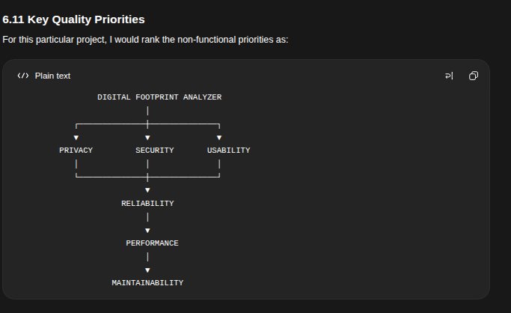

Data Flow Design
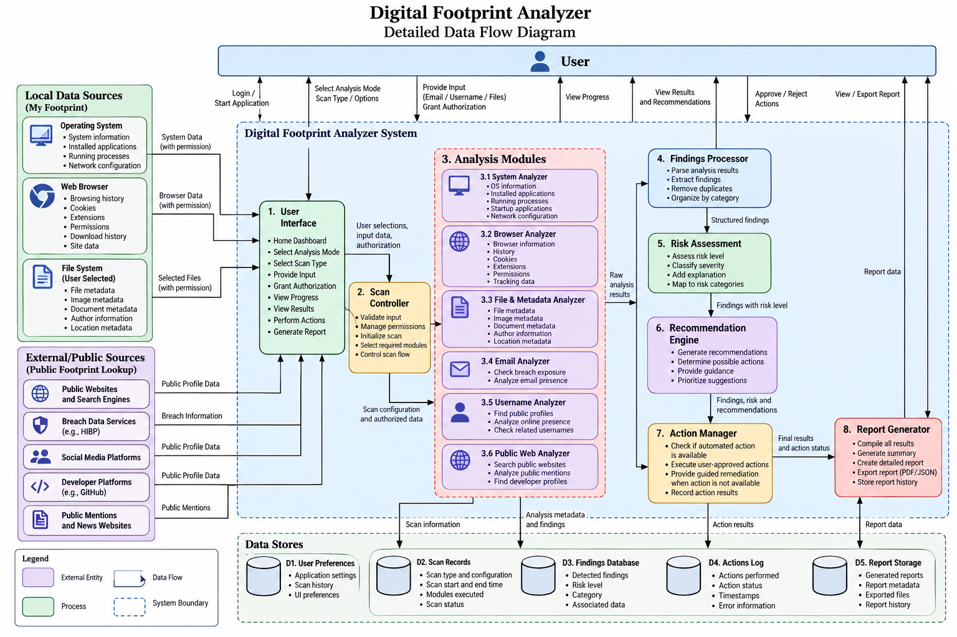

Step 8 — Data Design

8.1 Purpose of Data Design
The data design defines the major data entities required by the Digital Footprint Analyzer and the relationships between them.
At this stage, the design is conceptual. It does not decide the database technology, table structure, or implementation language.
The design focuses on:
- What information the system needs to represent
- What information is generated during a scan
- How findings and risks are related
- How recommendations and remediation actions are recorded
- How reports are generated
- How privacy-sensitive information is handled
The system follows a local-first and privacy-aware data design. Sensitive information should only be collected and retained when necessary for the selected analysis.

8.2 Main Data Entities
The Digital Footprint Analyzer contains the following major entities:
- User
- Session
- Scan
- Footprint Data
- Finding
- Risk Assessment
- Recommendation
- Remediation Action
- Report
- Data Source

8.3 Entity 1 — User
The User represents the individual operating the Digital Footprint Analyzer.
The system does not require a user account or login in the initial version.
Therefore, the User entity does not represent an online account. It represents the local application user and their preferences.

Main attributes
Attribute | Description
User ID | Unique identifier for the local user
Preferences | User-selected application preferences
Scan Preferences | Preferred scan settings
Authorization Preferences | Information related to user-approved access
Privacy Preferences | User-selected privacy settings
Created At | Time when the local user profile was initialized

Privacy considerations
The system should avoid collecting unnecessary personal information such as:
- Full name
- Phone number
- Address
- Date of birth
- Passwords
- Private account credentials
The User entity should primarily contain application preferences and consent-related information.

8.4 Entity 2 — Session
A Session represents one period of interaction between the user and the application.
Since there is no mandatory login system, the session provides the connection between the user and the scans performed during that application session.

Main attributes
Attribute | Description
Session ID | Unique identifier for the session
User ID | Reference to the local user
Start Time | Time when the session begins
End Time | Time when the session ends
Session Status | Current state of the session
Current Application State | Current activity or workflow state
Temporary Analysis Data | Temporary data required during analysis

Example
Session ID: SESSION-001
Start Time: 10:30 AM
End Time: 11:15 AM
Status: Completed

Privacy consideration
Temporary sensitive information should preferably be removed when it is no longer required.

8.5 Entity 3 — Scan
A Scan represents one analysis operation performed by the system.
A scan may be:
- Full Scan
- Individual Scan
It may also belong to either:
- My Footprint
- Public Footprint Lookup

Main attributes
Attribute | Description
Scan ID | Unique identifier of the scan
Session ID | Session associated with the scan
Analysis Mode | My Footprint / Public Footprint Lookup
Scan Type | Full Scan / Individual Scan
Scan Category | System / Browser / File / Email / Username / Public Presence etc.
Start Time | Scan start time
End Time | Scan completion time
Status | Current scan status
Input Reference | Identifier or input used for the scan
Authorization Status | Whether required authorization was granted
Result Reference | Reference to generated results

Scan status
The scan can have the following states:
PENDING
↓
AUTHORIZED / READY
↓
RUNNING
↓
COMPLETED
Alternative outcomes:
RUNNING → FAILED
RUNNING → CANCELLED

Example
Scan ID: SCAN-001
Analysis Mode: Public Footprint Lookup
Scan Type: Individual Scan
Category: Username
Input: username provided by user
Status: COMPLETED

Privacy consideration
Sensitive scan inputs should not be retained unnecessarily.
For example, browser history or private file contents should normally be processed temporarily rather than permanently stored.

8.6 Entity 4 — Footprint Data
Footprint Data represents the actual digital traces collected or identified during an analysis.
This is one of the most important entities because different scan modules produce different types of footprint information.

Categories of Footprint Data

System Footprint
Examples:
- Operating system
- Installed applications
- Running processes
- Startup applications
- Network configuration

Browser Footprint
Examples:
- Browser information
- Browser history
- Cookies
- Extensions
- Browser permissions
- Trackers
- Download history

File and Metadata Footprint
Examples:
- Local files
- Image metadata
- Document metadata

Online/Public Footprint
Examples:
- Email exposure
- Username presence
- Public profiles
- Social profiles
- Developer profiles
- Public web presence
- Public mentions
- Websites/domains
- Publicly indexed information

Main attributes
Attribute | Description
Footprint ID | Unique identifier
Scan ID | Scan that produced the footprint
Category | Type of footprint
Subcategory | More specific footprint type
Source | Where the information came from
Data Type | Type of information detected
Value/Reference | Detected information or reference
Detection Time | Time when the information was detected
Sensitivity | Sensitivity level of the information
Retention Status | Whether the information is temporarily or persistently retained

Example
Footprint ID: FP-001
Scan ID: SCAN-001
Category: Browser
Subcategory: Extension
Source: Web Browser
Data Type: Installed Extension
Value: Example Extension
Sensitivity: Medium

Privacy principle
The system should distinguish between:
Information required for analysis
↓
Temporary processing
↓
Result generation
↓
Delete unnecessary raw data
The system should preferably store the finding/result rather than unnecessary raw sensitive data.

8.7 Entity 5 — Finding
A Finding represents a specific digital footprint issue or observation identified by the system.
For example:
- An outdated browser extension
- Sensitive metadata in an image
- An exposed email address
- A public profile
- A potentially risky browser permission
- A public username association

Main attributes
Attribute | Description
Finding ID | Unique identifier
Scan ID | Scan that produced the finding
Footprint ID | Related footprint data
Finding Type | Type of issue or observation
Title | Short description
Description | Detailed explanation
Evidence Reference | Reference supporting the finding
Severity | Severity classification
Status | Current finding status
Detected At | Detection time

Example
Finding ID: FIND-001
Type: File Metadata
Title: Location metadata detected
Description: An image contains location information.
Severity: HIGH
Status: OPEN
The Finding entity should explain what was detected, rather than simply presenting raw technical information.

8.8 Entity 6 — Risk Assessment
The Risk Assessment represents the privacy or security risk associated with a finding.
A finding and a risk are related but not identical.
For example:
Finding:
Image contains GPS metadata

Risk:
Location information may reveal where the image was captured.

Main attributes
Attribute | Description
Risk ID | Unique identifier
Finding ID | Related finding
Risk Type | Privacy / Security / Both
Severity | Risk severity
Risk Score | Numerical or calculated risk value
Impact | Potential consequence
Likelihood | Estimated likelihood
Explanation | Reason for the assigned risk

Example
Risk ID: RISK-001
Finding: FIND-001
Risk Type: Privacy
Severity: HIGH
Impact: Location exposure
Likelihood: Medium

Important design principle
The system should distinguish between:
- Confirmed findings
- Potential risks
- Unknown/unverified information
This prevents the application from presenting uncertain information as fact.

8.9 Entity 7 — Recommendation
A Recommendation provides guidance to the user based on a finding or risk.
The recommendation should explain what the user can do and why it is useful.

Main attributes
Attribute | Description
Recommendation ID | Unique identifier
Finding ID | Related finding
Risk ID | Related risk
Title | Recommendation title
Description | Explanation
Priority | Recommendation priority
Action Availability | Whether the system can perform an action
Remediation Type | Direct / User-authorized / Guided
Instructions | Steps for the user

Example
Recommendation:
Remove location metadata before sharing the image.

Priority:
High

Remediation Type:
Direct Cleanup

Action Availability:
Available

8.10 Entity 8 — Remediation Action
A Remediation Action represents an action taken or approved by the user to reduce a detected footprint.
The system should never automatically perform sensitive cleanup without user confirmation.

Three remediation types

1. Direct Cleanup
The system can safely perform the action.
Example:
Remove metadata from a selected image

2. User-Authorized Cleanup
The system can perform the action after the user explicitly authorizes it.
Example:
Clear selected browser history

3. Guided Remediation
The system cannot directly perform the action, so it provides instructions.
Example:
Open the official account deletion page
Follow the provided instructions

Main attributes
Attribute | Description
Action ID | Unique identifier
Recommendation ID | Related recommendation
Finding ID | Related finding
Action Type | Direct / Authorized / Guided
Target Reference | Item affected by the action
User Confirmation | Whether user approved it
Execution Status | Pending / Executed / Failed / Cancelled
Execution Time | Time of action
Result | Result of the action
Error Details | Error information if applicable

Remediation workflow
DETECT
↓
EXPLAIN
↓
RECOMMEND
↓
USER SELECTS
↓
CONFIRM
↓
EXECUTE
↓
REPORT RESULT

8.11 Entity 9 — Report
The Report represents the summarized result of an analysis.
The report should allow the user to understand:
- What was analyzed
- What was found
- What risks were identified
- What recommendations were generated
- What remediation actions were performed

Main attributes
Attribute | Description
Report ID | Unique identifier
Scan ID | Associated scan
Report Type | Full / Individual
Generated At | Report generation time
Summary | Overall analysis summary
Findings Summary | Summary of detected findings
Risk Summary | Summary of identified risks
Recommendation Summary | Summary of recommendations
Remediation Summary | Summary of actions performed
Report Reference | Reference to generated report

Example
Report ID: REPORT-001

Scan:
SCAN-001

Findings:
12

High Risk:
2

Medium Risk:
5

Low Risk:
5

Recommendations:
8

Remediation Actions:
3
The exact dashboard and report design will be finalized later during UI/UX design.

8.12 Entity 10 — Data Source
The Data Source represents the origin of information used during an analysis.
This is important because the system may collect information from different sources.

Possible sources
- Operating System
- Web Browser
- File System
- Public Website
- Search Source
- External Breach/Data Service
- User-provided input

Main attributes
Attribute | Description
Source ID | Unique identifier
Source Type | OS / Browser / File System / Web / External Service etc.
Source Name | Name of source
Source Reference | Reference or endpoint where appropriate
Access Type | Local / Public / User Authorized
Collection Time | Time information was obtained
Reliability | Reliability or confidence information

Entity Relationship Overview

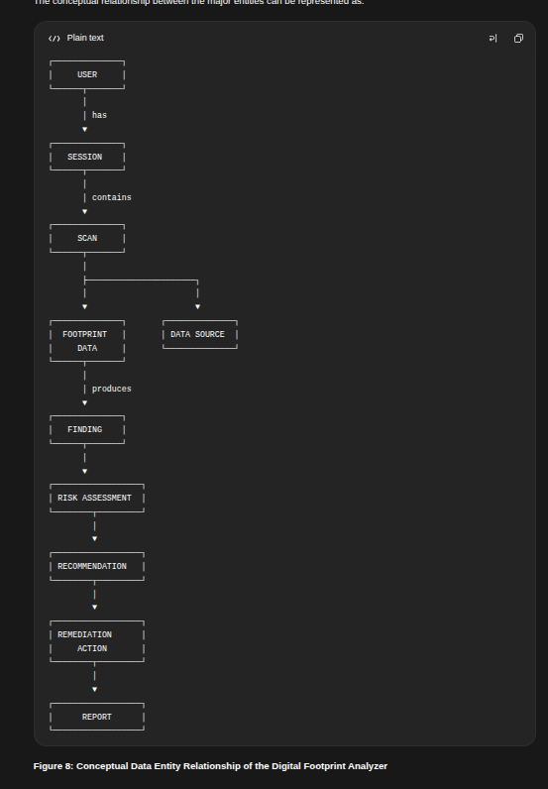
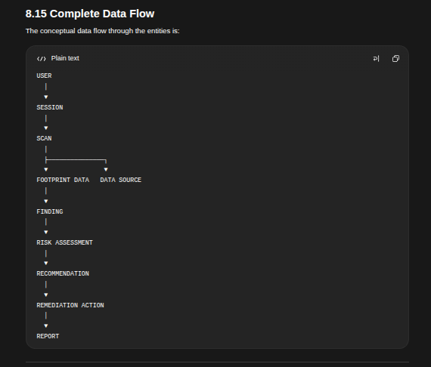

8.16 Privacy-Aware Data Design
Because the application deals with potentially sensitive digital footprint information, privacy is an important part of the data design.
The system should follow these principles:

1. Minimum Data Collection
Only collect information required for the selected analysis.

2. Temporary Processing
Sensitive information such as browser history and private file metadata should preferably be processed temporarily.

3. Avoid Raw Sensitive Storage
The system should avoid storing unnecessary raw information such as:
- Passwords
- Private messages
- Complete browsing history
- Private file contents
- Authentication tokens

4. User Authorization
Access to sensitive local information should require appropriate user authorization.

5. User-Controlled Remediation
No sensitive cleanup action should be performed without user confirmation.

6. Transparent Results
The user should be able to understand:
What was accessed
↓
What was detected
↓
Why it matters
↓
What can be done

7. No Unauthorized Access
The application must not attempt to bypass:
- Authentication
- CAPTCHA
- Access controls
- Privacy restrictions
- Security mechanisms

Component design
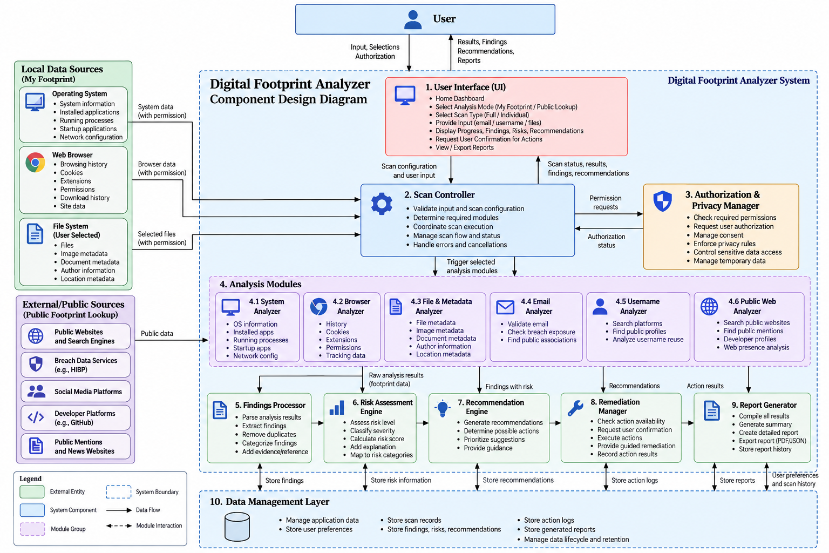

Component Interaction / Sequence Design
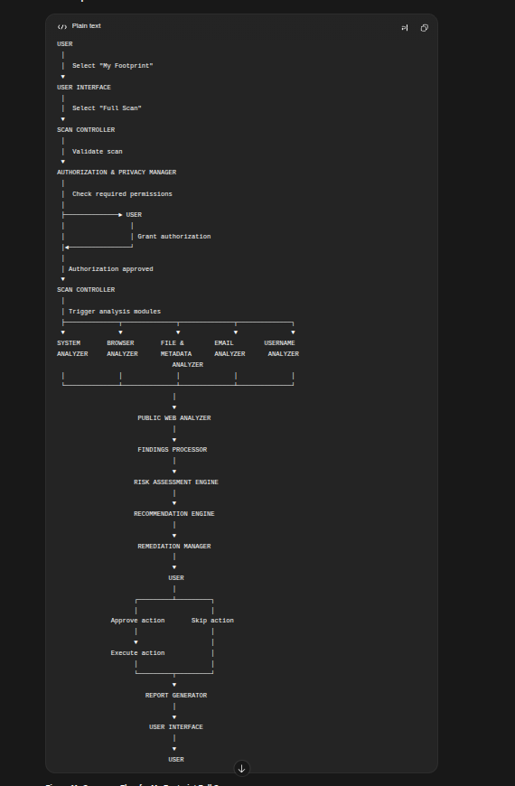

10.3 Detailed Interaction Steps
Step | Component | Action
1 | User | Opens the application
2 | UI | Displays Home Dashboard
3 | User | Selects My Footprint
4 | UI | Displays available scan types
5 | User | Selects Full Scan
6 | UI | Sends scan configuration to Scan Controller
7 | Scan Controller | Validates the scan configuration
8 | Authorization Manager | Determines required permissions
9 | UI/User | Requests and grants required authorization
10 | Authorization Manager | Returns authorization status
11 | Scan Controller | Starts the scan
12 | System Analyzer | Collects authorized system information
13 | Browser Analyzer | Collects authorized browser information
14 | File & Metadata Analyzer | Analyzes authorized files/metadata
15 | Email Analyzer | Performs supported email analysis
16 | Username Analyzer | Performs supported username analysis
17 | Public Web Analyzer | Performs supported public presence analysis
18 | Analysis Modules | Return footprint data
19 | Findings Processor | Converts results into structured findings
20 | Risk Assessment Engine | Assesses privacy/security risks
21 | Recommendation Engine | Generates recommendations
22 | UI | Displays findings, risks and recommendations
23 | User | Reviews recommendations
24 | User | Selects desired remediation actions
25 | Remediation Manager | Requests confirmation
26 | User | Confirms or cancels action
27 | Remediation Manager | Executes feasible action or provides guidance
28 | Report Generator | Generates analysis report
29 | UI | Displays final results/report
30 | User | Reviews the completed analysis

10.4 Important Interaction Rule
The analysis modules should not directly control remediation.
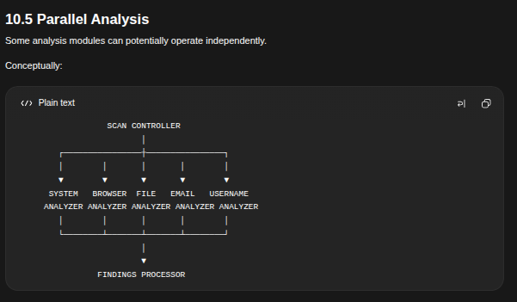
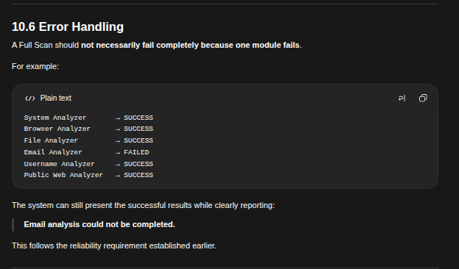
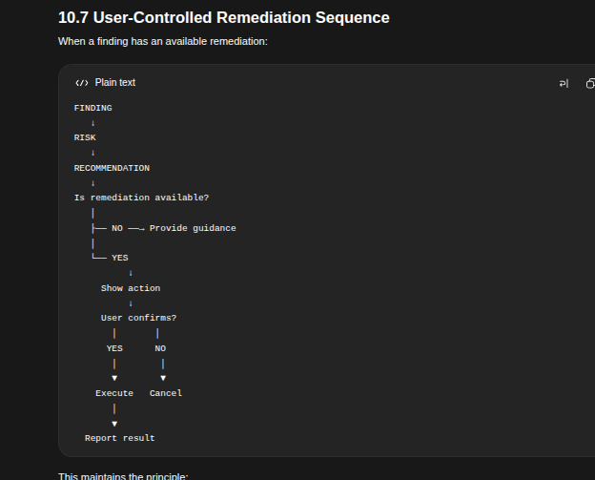
Step 10.2 — My Footprint → Individual Scan
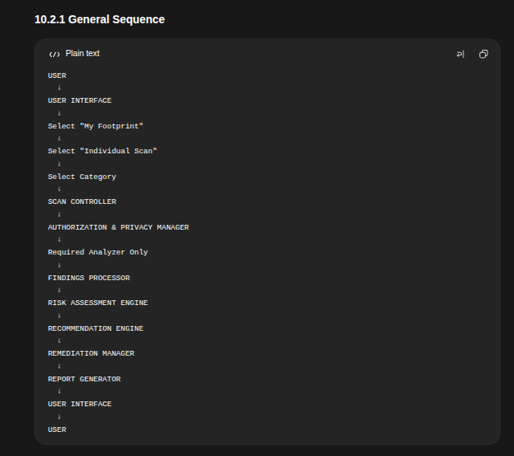

10.2.2 Detailed Interaction
Step | Component | Action
1 | User | Opens the application
2 | UI | Displays Home Dashboard
3 | User | Selects My Footprint
4 | UI | Displays scan options
5 | User | Selects Individual Scan
6 | UI | Displays available categories
7 | User | Selects a category
8 | UI | Sends scan configuration to Scan Controller
9 | Scan Controller | Validates the configuration
10 | Authorization Manager | Determines required permissions
11 | User | Grants required authorization
12 | Authorization Manager | Returns authorization status
13 | Scan Controller | Starts the selected analyzer
14 | Selected Analyzer | Collects and analyzes required information
15 | Analyzer | Returns footprint data
16 | Findings Processor | Processes the analysis results
17 | Risk Assessment Engine | Assesses identified risks
18 | Recommendation Engine | Generates recommendations
19 | UI | Displays findings, risks and recommendations
20 | User | Reviews the results
21 | User | Selects remediation if available
22 | Remediation Manager | Requests confirmation
23 | User | Confirms or cancels
24 | Remediation Manager | Executes approved action or provides guidance
25 | Report Generator | Generates the report
26 | UI | Displays final results
27 | User | Views the report

Step 10.3 — Public Footprint Lookup → Full Scan

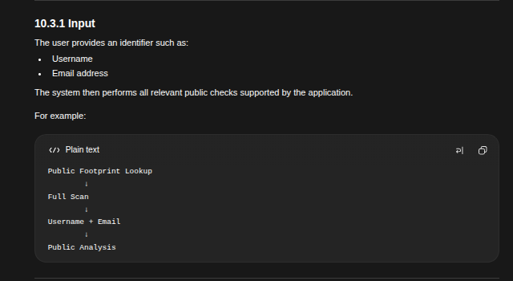
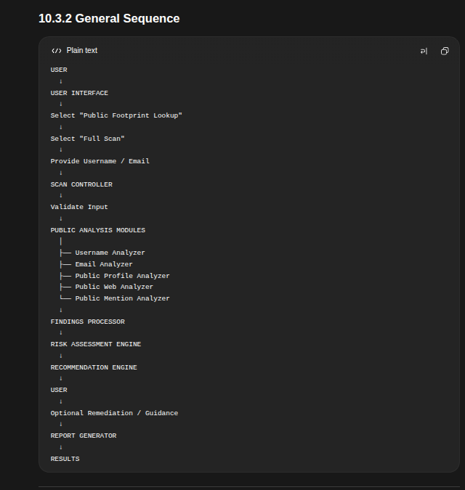

10.3.3 Detailed Interaction
Step | Component | Action
1 | User | Opens the application
2 | UI | Displays Home Dashboard
3 | User | Selects Public Footprint Lookup
4 | UI | Displays available scan types
5 | User | Selects Full Scan
6 | UI | Requests required identifier
7 | User | Provides username/email
8 | UI | Sends input to Scan Controller
9 | Scan Controller | Validates the input
10 | Scan Controller | Determines applicable public analysis modules
11 | Username Analyzer | Checks supported public username presence
12 | Email Analyzer | Performs supported email exposure analysis
13 | Public Profile Analyzer | Identifies relevant public profiles
14 | Public Web Analyzer | Checks supported public web presence
15 | Public Mention Analyzer | Checks supported public mentions
16 | Analysis modules | Return public footprint results
17 | Findings Processor | Processes and normalizes results
18 | Risk Assessment Engine | Assesses privacy/security risks
19 | Recommendation Engine | Generates recommendations
20 | UI | Displays findings and risks
21 | User | Reviews recommendations
22 | User | Selects available actions if applicable
23 | Remediation Manager | Provides user-controlled remediation or guidance
24 | Report Generator | Generates report
25 | UI | Displays final report
26 | User | Reviews results
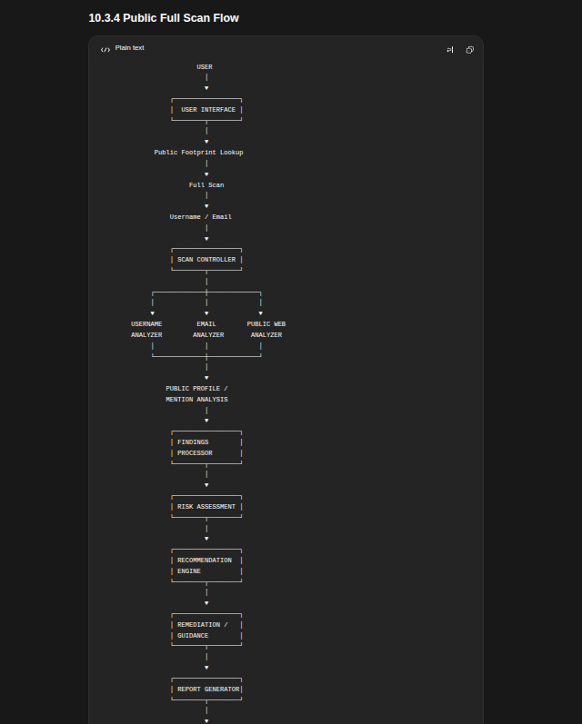

Step 10.4 — Public Footprint Lookup → Individual Scan
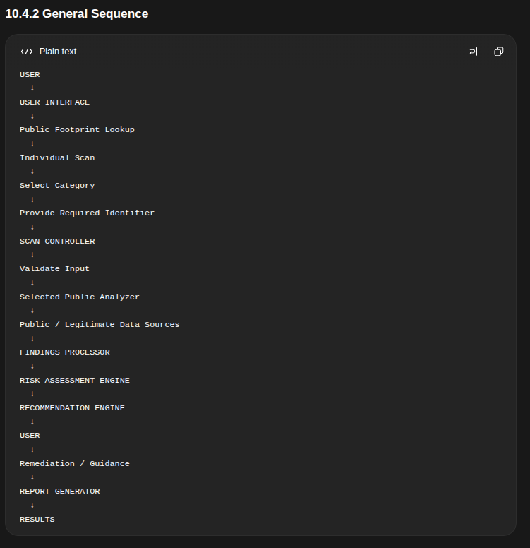

10.4.3 Detailed Interaction
Step | Component | Action
1 | User | Opens application
2 | UI | Displays Home Dashboard
3 | User | Selects Public Footprint Lookup
4 | UI | Displays scan options
5 | User | Selects Individual Scan
6 | UI | Displays public scan categories
7 | User | Selects a category
8 | UI | Requests required identifier
9 | User | Provides username/email or relevant input
10 | Scan Controller | Validates input
11 | Scan Controller | Selects required analyzer
12 | Analyzer | Collects publicly accessible information
13 | Analyzer | Returns analysis results
14 | Findings Processor | Processes results
15 | Risk Assessment Engine | Assesses risks
16 | Recommendation Engine | Generates recommendations
17 | UI | Displays findings and recommendations
18 | User | Reviews results
19 | User | Selects available action if applicable
20 | Remediation Manager | Provides guided/user-authorized remediation
21 | Report Generator | Generates report
22 | UI | Displays final report

Step 10.5 — Remediation Sequence
Now we define how the system handles a finding that can potentially be reduced or removed.
This sequence applies to both:

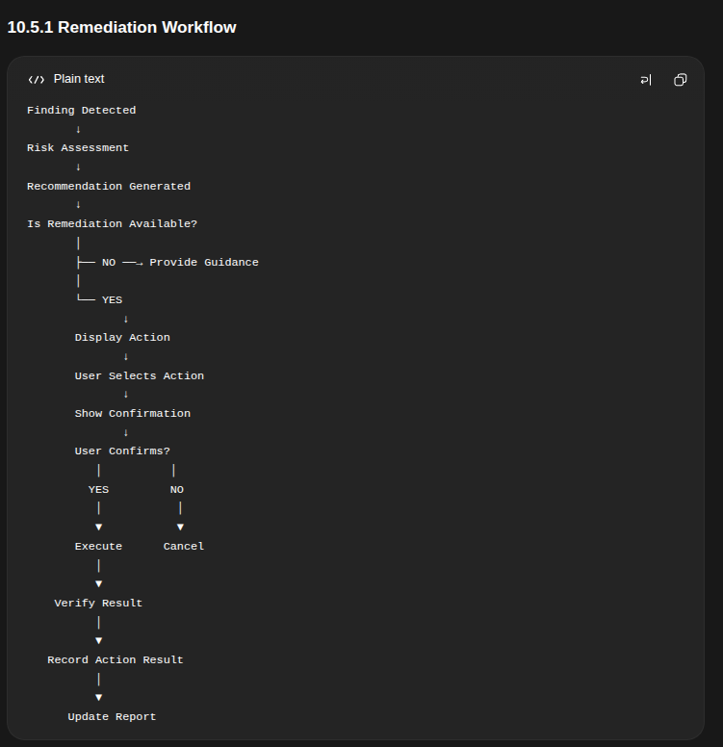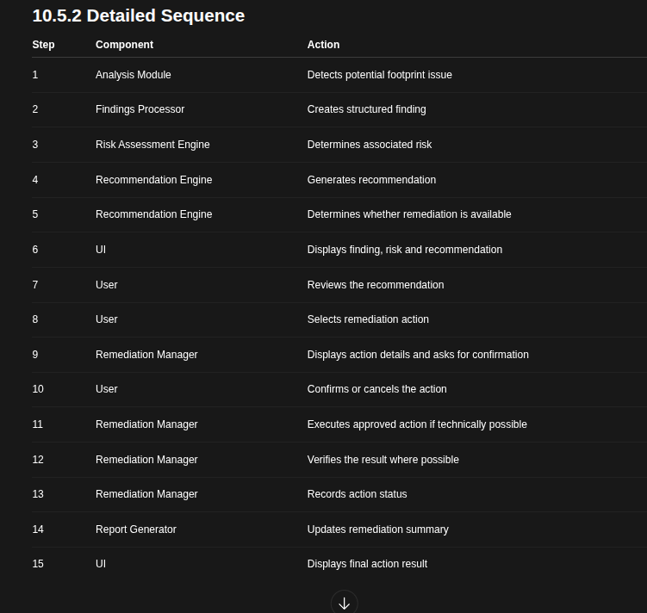

Step 11 — Security & Privacy Design
Now we move to Security and Privacy Design.
This is a particularly important part of the Digital Footprint Analyzer because the application itself handles potentially sensitive information such as browser data, files, metadata, email identifiers, usernames, and public-profile information.
The main principle is:
The Digital Footprint Analyzer must protect the user's data while analyzing the user's digital footprint.

11.1 Security and Privacy Objectives
The system should achieve the following objectives:
- Prevent unauthorized access to user data.
- Collect only the information required for the selected scan.
- Obtain user authorization before accessing sensitive local information.
- Avoid unnecessary permanent storage of sensitive data.
- Protect communication with external services.
- Prevent unauthorized remediation actions.
- Clearly inform users about what information is being accessed.
- Maintain the distinction between confirmed information and uncertain results.
- Prevent the application from bypassing security mechanisms.
- Give the user control over their data and remediation actions.

11.2 Security & Privacy Principles
The design follows these principles:

1. Privacy by Design
Privacy is considered throughout the system rather than added after implementation.
Design
↓
Collection
↓
Processing
↓
Storage
↓
Remediation
Privacy requirements apply to every stage.

2. Data Minimization
The system should collect only what is necessary for the selected operation.
For example, if the user selects:
File & Metadata Scan
the application should not collect unrelated browser history.

3. User Authorization
Sensitive operations should require appropriate user authorization.
Scan Requested
↓
Permission Required?
↓
YES
↓
Explain Access
↓
User Authorizes
↓
Perform Scan

4. User Control
The user should remain in control of:
- What is scanned
- Which files are selected
- Which public identifier is searched
- Which remediation actions are performed
- What information is retained

5. No Unauthorized Access
The system must not attempt to:
- Bypass authentication
- Bypass CAPTCHA
- Access private accounts
- Access private messages
- Obtain passwords
- Obtain authentication tokens
- Circumvent access controls
- Access another user's local system

11.3 Authorization Design
Authorization is particularly important for My Footprint.
Different scans require different levels of access.

Scan | Example Access
System Scan | OS/system information
Browser Scan | Browser-related data
File Scan | User-selected files/directories
Email Scan | User-provided email identifier
Username Scan | User-provided username
Public Presence | Public/legitimate web sources
The system should request permissions when they are needed, rather than requesting every permission when the application starts.

11.4 Permission Workflow
USER SELECTS SCAN
↓
SYSTEM IDENTIFIES REQUIRED ACCESS
↓
IS AUTHORIZATION REQUIRED?
│
┌────┴────┐
│ │
NO YES
│ │
│ ▼
│ EXPLAIN ACCESS
│ │
│ ▼
│ REQUEST AUTHORIZATION
│ │
│ ┌────┴────┐
│ │ │
│ GRANT DENY
│ │ │
│ ▼ ▼
└─► SCAN CANCEL / LIMITED SCAN

11.5 Sensitive Data Handling
The application may encounter sensitive information during analysis.
Examples include:
- Browser history
- Cookies
- Download history
- File metadata
- Network information
- Email identifiers
- Usernames
The system should distinguish between:

Raw Data
The original information collected during analysis.

Processed Result
The information required to explain the finding.
For example:
Raw Data:
Complete browser history

↓

Analysis

↓

Finding:
Potential tracking-related history detected
The system should avoid storing the entire raw dataset if the finding can be generated without retaining it.

11.6 Temporary Processing
Sensitive information should preferably be processed temporarily.
Collect
↓
Analyze
↓
Generate Finding
↓
Keep Required Result
↓
Discard Unnecessary Raw Data
This reduces the amount of sensitive information that remains inside the application.

11.7 Local Data Protection
If scan results or user preferences are stored locally, they should be protected against unauthorized access.
The design should consider:
- Restricted file permissions
- Protected application storage
- Secure handling of sensitive values
- Avoiding unnecessary raw-data storage
- Safe deletion of temporary information
The exact storage technology will be selected later during architecture design.

11.8 External Service Security
The Public Footprint Lookup may communicate with external services.
Examples include:
- Public websites
- Search sources
- Breach/data services
- Public developer platforms
The system should:
- Use secure communication
- Validate external responses
- Avoid sending unnecessary personal information
- Handle service failures safely
- Avoid exposing sensitive information in requests
- Store API credentials securely if required

11.9 API Key Protection
If an external service requires an API key:
❌ Do NOT place the key directly in source code
❌ Do NOT commit the key to GitHub
❌ Do NOT expose the key in the frontend
Instead, the implementation should use appropriate protected configuration mechanisms.
For example:
Application
↓
Protected Configuration
↓
API Credential
↓
External Service
The exact implementation will be decided later.

11.10 Public Footprint Privacy
Public Footprint Lookup must follow a strict boundary.
The system may analyze:
Publicly Accessible Information
↓
Legitimate Analysis
↓
Finding
It must not attempt:
Private Account
Private Message
Password
Authentication Token
Restricted Database
↓
❌ NOT ALLOWED

11.11 Identity Confidence
A public result does not automatically prove that it belongs to the user.
For example:
Username Found
≠
Identity Confirmed
Therefore, findings should ideally include a confidence or verification state such as:
- Confirmed
- Potential Match
- Unverified
- Unknown
This helps reduce false conclusions.

11.12 Remediation Security
Remediation actions must be protected because they can modify user data.
The system should follow:
Finding
↓
Recommendation
↓
Action Available
↓
User Selects
↓
Confirmation
↓
Execute
There should be no silent destructive action.
For potentially irreversible operations, the application should clearly explain:
- What will be changed
- What will be removed
- Whether the action can be reversed
- What the expected result is

11.13 Remediation Verification
After a remediation action, the system should verify the result where technically possible.
Example:
Remove Metadata
↓
Re-analyze File
↓
Metadata Still Present?
│
┌────┴────┐
NO YES
│ │
▼ ▼
Success Failed
If verification is not technically possible, the system should report:
Action completed, but the result could not be independently verified.
It should not falsely claim that the footprint has been completely removed.

11.14 Security Logging
The system may maintain security-related logs for important operations.
Examples:
- Scan started
- Authorization granted/denied
- Remediation approved
- Remediation executed
- Remediation failed
However, logs should not unnecessarily contain sensitive information.
For example:
GOOD:
"Browser cleanup action executed."

AVOID:
"Full browser history: [entire history contents]"

11.15 Error Handling and Privacy
Errors should not expose sensitive information.
For example, an error message should avoid displaying:
- Passwords
- Authentication tokens
- Full private file contents
- Complete browser history
- Sensitive API credentials
Instead:
❌ Error: API key ABC123... failed

Better:

✓ External service authentication failed.

11.16 Security Design Overview
The overall security flow can be represented as:
┌───────────────────┐
│ USER │
└─────────┬─────────┘
│
▼
┌───────────────────┐
│ USER INTERFACE │
└─────────┬─────────┘
│
▼
┌──────────────────────────┐
│ AUTHORIZATION & PRIVACY │
│ MANAGER │
└────────────┬─────────────┘
│
┌─────────────┼─────────────┐
▼ ▼ ▼
SYSTEM DATA BROWSER DATA FILE DATA
│ │ │
└─────────────┼─────────────┘
▼
┌───────────────────┐
│ ANALYSIS │
└─────────┬─────────┘
│
▼
┌───────────────────┐
│ FINDINGS │
└─────────┬─────────┘
│
▼
┌───────────────────┐
│ RISK ASSESSMENT │
└─────────┬─────────┘
│
▼
┌───────────────────┐
│ RECOMMENDATIONS │
└─────────┬─────────┘
│
▼
┌───────────────────┐
│ USER CONFIRMATION │
└─────────┬─────────┘
│
▼
┌───────────────────┐
│ REMEDIATION │
└─────────┬─────────┘
│
▼
┌───────────────────┐
│ REPORT │
└───────────────────┘
Figure 13: Security and Privacy Control Flow

11.17 Security Requirements Summary

ID | Requirement
SEC-01 | The system shall require appropriate authorization before accessing sensitive local information.
SEC-02 | The system shall follow the principle of minimum necessary data collection.
SEC-03 | The system shall avoid unnecessary storage of raw sensitive information.
SEC-04 | The system shall not bypass authentication, CAPTCHA, or other access controls.
SEC-05 | External communications shall use secure communication mechanisms where applicable.
SEC-06 | API credentials shall not be exposed in source code or the frontend.
SEC-07 | Remediation actions shall require explicit user confirmation.
SEC-08 | The system shall distinguish confirmed information from potential or unverified findings.
SEC-09 | Error messages and logs shall not unnecessarily expose sensitive information.
SEC-10 | The system shall protect locally stored application data from unauthorized access.
SEC-11 | The system shall verify remediation results where technically possible.
SEC-12 | The system shall not claim complete footprint removal when only partial remediation has been performed.
